|  |  |
| --- | --- |
|  | **DEC40053-EMBEDDED SYSTEM AND APPLICATION** |
|  | ***POLITEKNIK SULTAN ABDUL HALIM MU’ADZAM SHAH*** |

|  |
| --- |
| **[LAB4- PIC18F4550 INTERFACE WITH LCD DISPLAY]** |
|  |

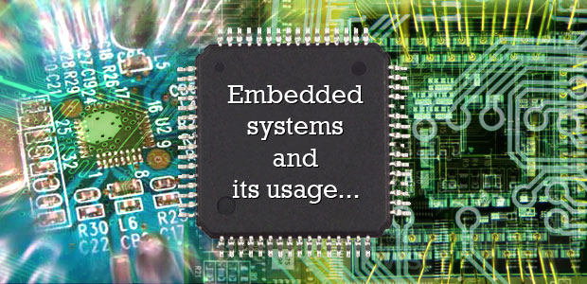

TITLE : PIC18F4550 INTERFACE WITH LCD DISPLAY

GOAL : To expose student with MPLAB IDE and Proteus software

CLO : (3) Construct and simulate embedded system application based on PIC 16f/PIC18F microcontroller effectively.

1. **OBJECTIVES**

At the end of the practical session, student should be able to:

1. To learn on how to interface the 2x16 character LCD to the PIC18F4550 microcontroller
2. Write c18 program for PIC Microcontroller’s to display character on LCD display
3. Use PROTEUS 7 Professional to observe LEDs and SWITCH simulation
4. **SYNOPSIS**

**Introduction to LCD**

The 2x16 character LCD offers character display for embedded system. It can be used to display numerical information, text message and also special symbol. We can control a LCD using either 8 pins (8-bit interface) or 4 pins (4-bit interface), depending on the I/O pins that we have. For learning purposes, we would recommend 8-bit interface which is relatively easy. Figure 4.1 shows the schematic for LCD connection in PTK40A.

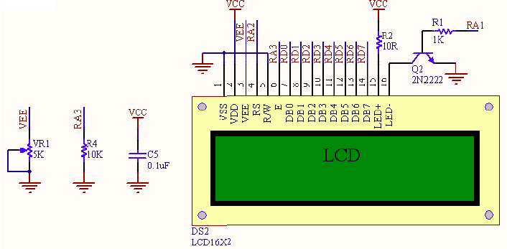

**Figure 4.1:** Connection of a 2x16 character LCD

**Controlling LCD**

Before using the LCD for display purpose, LCD has to be initialized either by the internal reset circuit or sending the commands to initialize the LCD. Given below is a flowchart that describes the step to follow to initialize the LCD. After initialize the LCD, it can be easily displayed any character on the LCD by sending the character in ASCII format to the data pins which are located at pin 7 to pin 14.

This routine set the location of the LCD (2X16) cursor.

If the given value is (0-15) the cursor will be at the upper line.

If the given value is (20-35) the cursor

will be at the lower line.

-------------------------------------------------------------

| |00|01|02|03|04|05|06|07|08|09|10|11|12|13|14|15| |

| |20|21|22|23|24|25|26|27|28|29|30|31|32|33|34|35| |

-----------------------------------------------------------

Therefore, to program the location of character, we should identify the address. To put at first line, first location as shown in the above diagram it shows 00. But, to program the location we should put 0x80. For first line 5th column, it should be 0x84. For second line, it use a different address. It is begin with 0xC0.

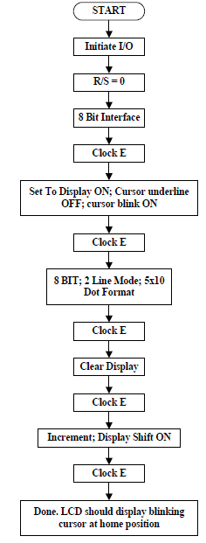

Figure 4.2: Flow chart of LCD initialization

**Programming Steps:**

Before displaying anything on LCD, it needs to be configured with proper instructions. The following programming steps explain the procedure of configuring the LCD and display a character on it.

**Step 1**: Initialize the LCD.

The LCD must be initialized the by following pre-defined commands of character LCD.

* 0x38, to configure the LCD for 2-line, 5x7 font and 8-bit operation mode
* 0x0C, for Display On and Cursor Off
* 0x01, to Clear Display screen
* 0x06, to increment cursor
* 0x80, to set cursor position at first block of the first line of LCD.

 The above set of commands is written in lcd_ini() function of the adjoining code.

**Step 2**: Send the commands to LCD.

* Send the command byte to the port connected to LCD data pins
* rs=0, to select command register of LCD
* rs=0, to set the LCD in writing mode. Regarding to PTK40A trainer, RW pin has been grounded.
* en=1, a high to low pulse to latch command instruction
* Delay of 1ms
* en=0

 The above set of commands is written in lcdcmd(unsigned char) function.

**Step 3**: Send data to LCD.

·         Send data at the port which connected to LCD data pins

·         RS=1, register select to select data register of LCD

·         RW=0, this set the LCD in writing mode

·         EN=1, a high to low pulse to latch data

·         Delay of 1ms

·         EN=0

The lcddata(unsigned char) function has the above set of instructions.

**Step 4**: Display character on LCD.

The functions lcdcmd() and lcddata() are user-defined functions. They are used to send a character (A in this case) to be displayed on LCD.

lcdcmd(0x80);             // send command 0x80 for location 1st line, 1st column to LCD

lcddata(‘A’);                // send character A to LCD

lcdcmd(0x80);             // send command 0xC7 for location 2nd line, 8th column to LCD

lcddata(‘M’);               // send character M to LCD

**3- EQUIPMENT LIST**

1. MPLAB IDE integrates with C18 compiler.
2. PROTEUS 7 Professional
3. Trainer Kit.

**4- PROCEDURE**

1. Create Project File with following setting:

* Device : PIC18F4550
* Active Toolsuite : Microchip C18 Toolsuite
* Project Name: LAB5-NO PENDAFTARAN PELAJAR

1. Import the given .c file and .h file into project as shown in Figure 5.3 below.

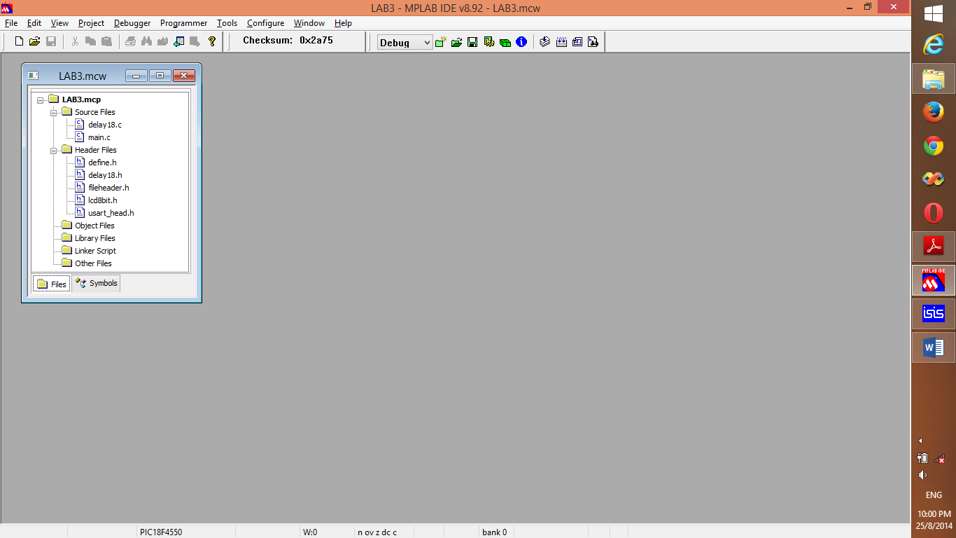

Figure 4.3: Project File

1. Open “main.c” file, and then “Build All”. Show the successfully build project to your lecture.

Endorse by:

1. Redraw the given schematic illustrate in Appendix A1.
2. Edit Properties of PIC18F4550 as shown in Figure 4.4 below:

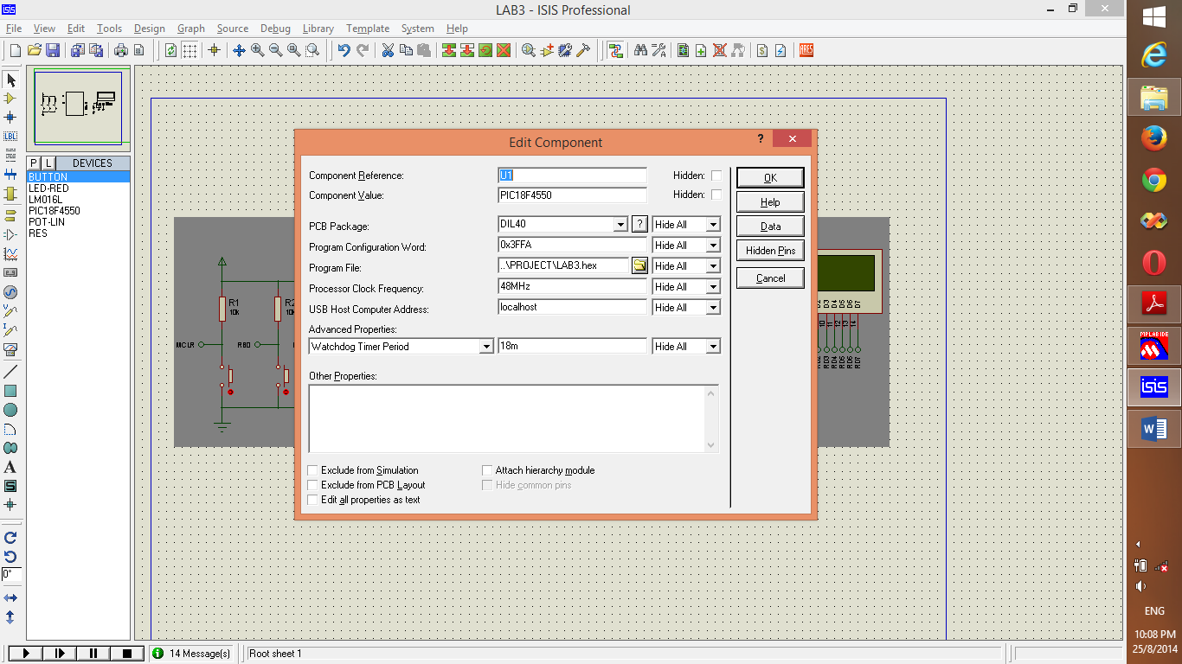

Figure 4.4: Properties of PIC18F4550

Make sure Load Program File into PIC18F4550 before run the simulation

Endorse by:

6. Run Simulation, and show the Virtual Terminal Output to your lecture.

7 Write code 1 below and observe the output at LCD

|  |
| --- |
|  |

Code 1: Display character on LCD.

Observation:

_____________________________________________________________________

_____________________________________________________________________

Task:

1. Modify the code1 to display the “A” and “B” character at middle of LCD
2. Modify the code 1 to display “A” at top left side and “B” at bottom right side of LCD

8. Write code 2 and observe the output at LCD

|  |
| --- |
|  |

Code 2: Program display string on LCD

Observation:

_____________________________________________________________________

_____________________________________________________________________

Task:

1. Modify the code2 to display the following message:

“ Hai,My Name is

Type your name”

1. Modify the code 2 by adding the following code at line 16.

Line 16 delay_ms(1000);

Line 17 lcd_clr( );

Line 18 while(1);

Question:

What is the benefit of **lcd_clr()** function?

__________________________________________________________________

9. Write code 3 and observe the output at LCD

|  |
| --- |
|  |

Code 3: Program to convert BCD to ASCII

Observation:

_____________________________________________________________________

_____________________________________________________________________

**5-TASK:**

Write c18 program according to pseudo code below:

a)

START

Display “Hai Good Morning Sir” at LCD screen

While

Start

If SW1 at RB0 is press

Then Display “Please Close the door” at LCD screen

Wait until SW1 is unpress

Display “Selamat jalan tuan” at LCD screen

End

END

b)

START

While

Start

If SW2 at RB1 is press

Display “Welcome”

i = i+1;

Display “No Giliran: i” at LCD screen

End

END

**DISCUSSION**

**CONCLUSION**

Appendix A1

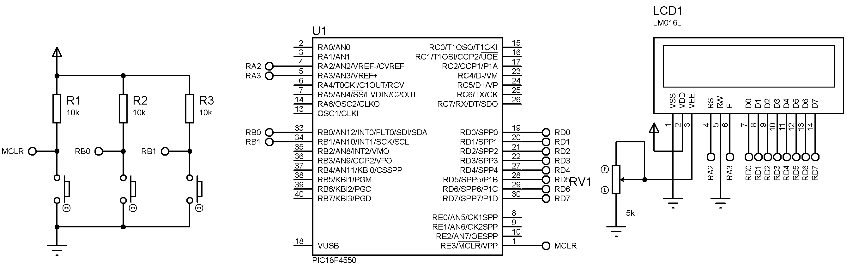

Component List:

Place > Component>

* + 1. RES
    2. LM016L
    3. LED-RED
    4. BUTTON
    5. PIC18F4550

Place > Terminal >

1. POWER
2. GROUND
3. DEFAULT